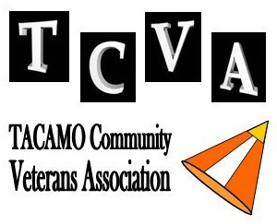
TACAMO Hall of Fame Nomination Form
Criteria for Induction to the TACAMO Hall of Fame

Guidelines for TACAMO Hall of Fame induction:
• Minimum 2 tours in TACAMO (or equivalent time)
• Contributed to the mission, the aircraft, morale and the good reputation of TACAMO
• Demonstrated leadership, technically, professionally and personally. A mentor
• Performs community service for the TACAMO Community
• Performed some sort of extraordinary task or event that shaped the TACAMO mission
• Generally recognized by his/her peers as deserving of this award

TCVA selects 5 to 6 Inductees per year in the categories of TACAMO Sailor, Industry Partner, Government Support, Posthumous, or Community Service
——————————————————————————
Nominator Information (Person Nominating)
- Nominator's Name:

- Relationship to Nominee:
- Nominator's email address:
- Phone number:
- TCVA Membership Status (choose one): None, Casual, Active or Life
- Nominator's TACAMO Experience: (especially as it relates to the nominee

——————————————————————————

Nominee Information
  - Nominee's Full Name:
  - Nominee's Rate/Rank/Position:
  - Nominee's Military Status: Active Duty / Veteran / Retired / Civilian
  - Category of Nomination (Select One or Two):
    - TACAMO Sailor
    - Industry Partner
    - Civilian Gov't Support
    - Customer Service
    - Posthumous

Nominee's Contact information (if known)
Street Address:

City: State: Zip:

Email address:

Phone Number:

Supporting Information:

  - List nominee's time in TACAMO (Requirement: Minimum 2 tours in TACAMO)

  - Please provide names and contact info on other shipmates who served with the nominee

  - Describe the significant, lasting contributions the nominee contributed to the mission/aircraft/morale/good reputation of TACAMO.

  - Describe your nominee's Technical/professional/personal leadership - a mentor.

  - Describe your nominee's performed task or event that shaped the TACAMO mission.

  - Describe your nominee's community service, include past and present volunteer associations.

  - SUMMARY STATEMENT: I believe this nominee should be inducted into the TACAMO Hall of Fame because:

